Trialing Document

|  |  |
| --- | --- |
| Date | What is the thing I am trialing |
| 21/05/24 | Find out the Y coordinate as a integer for the arrays (because our y coordinate is alpabet) |

*Copy and paste the table above before filling it out*

### Version A

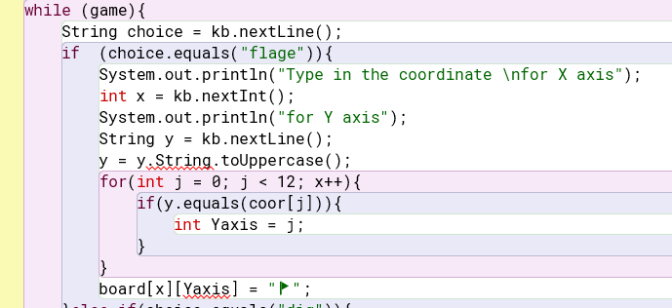

My comments….

### Version B

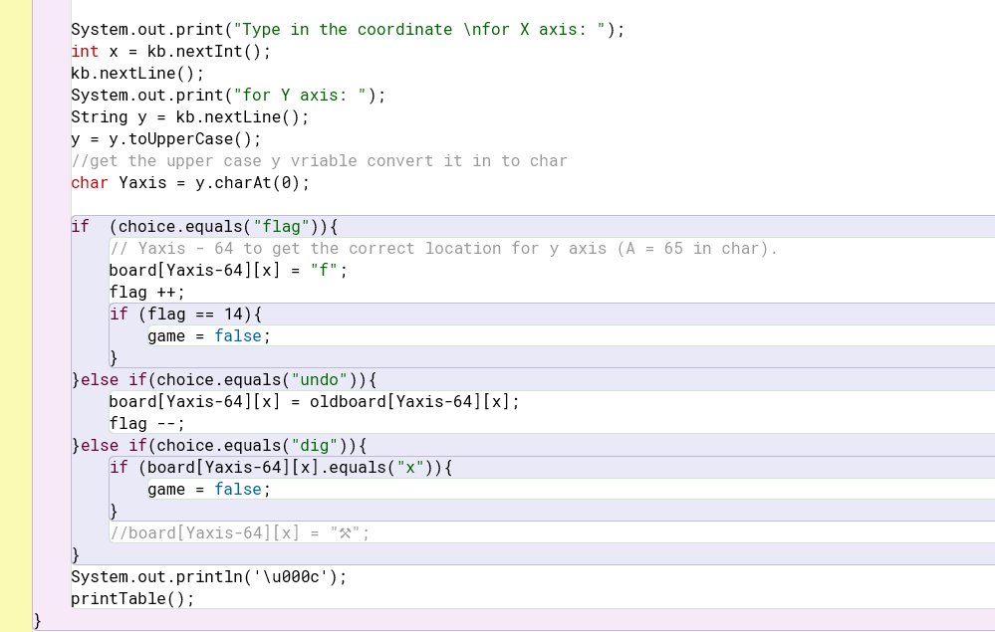

My comments….

### Feedback

Person:

Date:

Comment:

Person:

Date:

Comment

### Evaluation and next steps

Based on this trialing and the feedback, I have decided…